FADEL MATAR

CUMULATIVE 2 EVEDENCES:

1. API that adds a Teacher using POST Data

1. API that deletes a Teacher

3- web page that allows a user to enter new Teacher information

Link to add teacher page

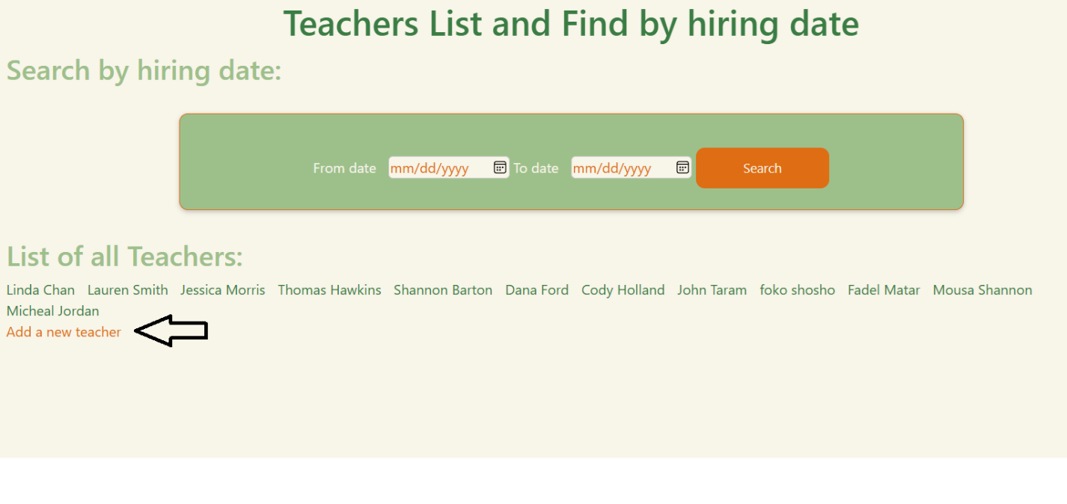

Add teacher page (courses is an extra optional property I added in Teachers model in cumulative 1)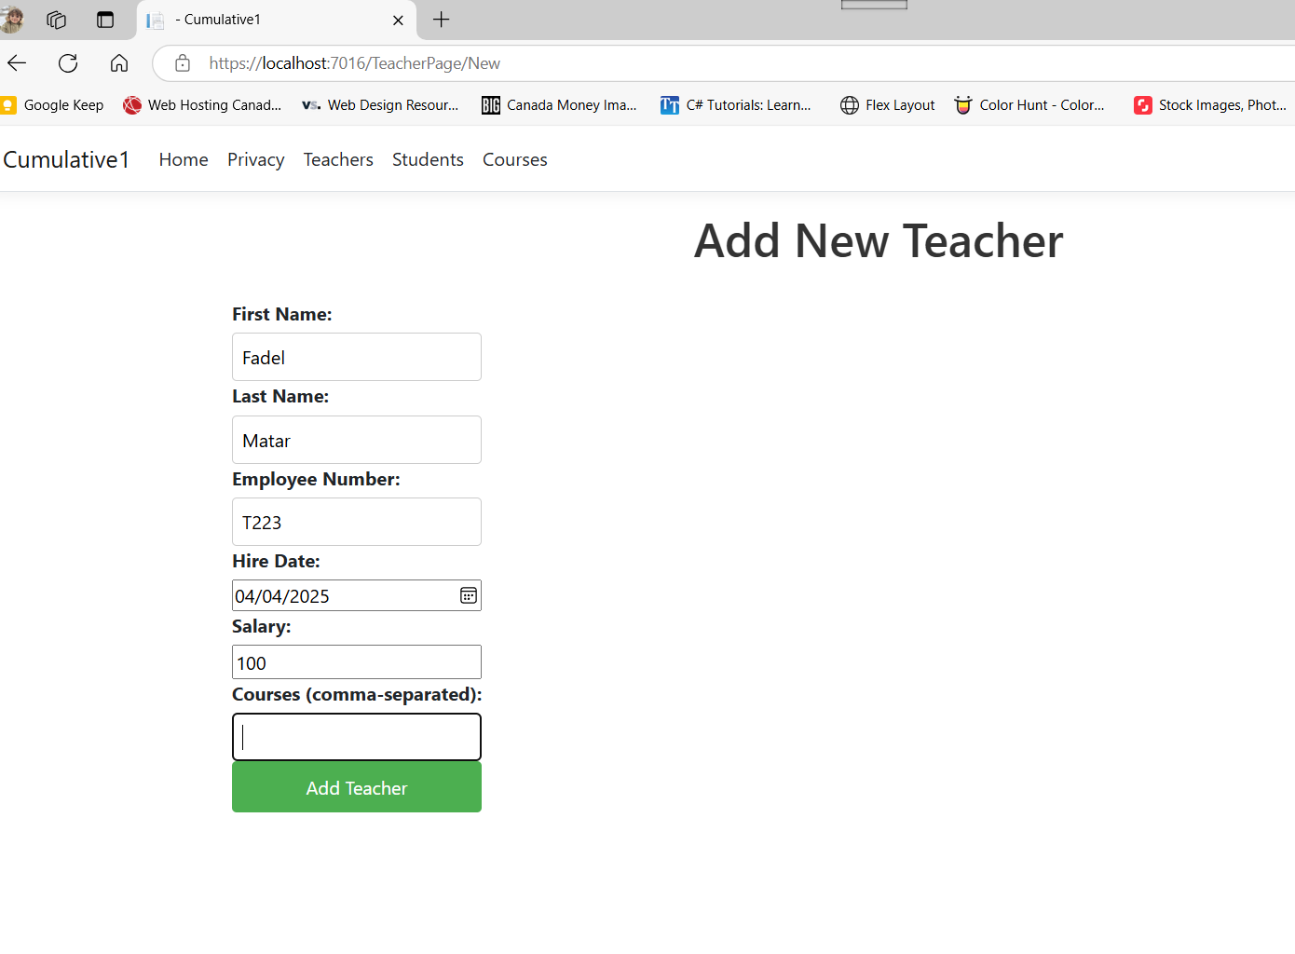

After adding the above teacher(fadel) the page redirects to the teachers list

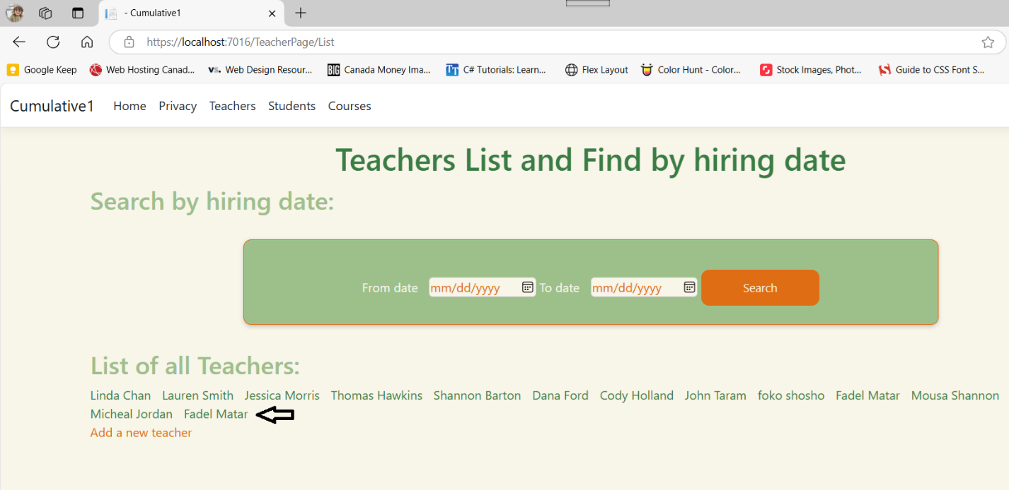

4-web page that confirms the action to delete a Teacher

Delete Teacher Link under teacher details

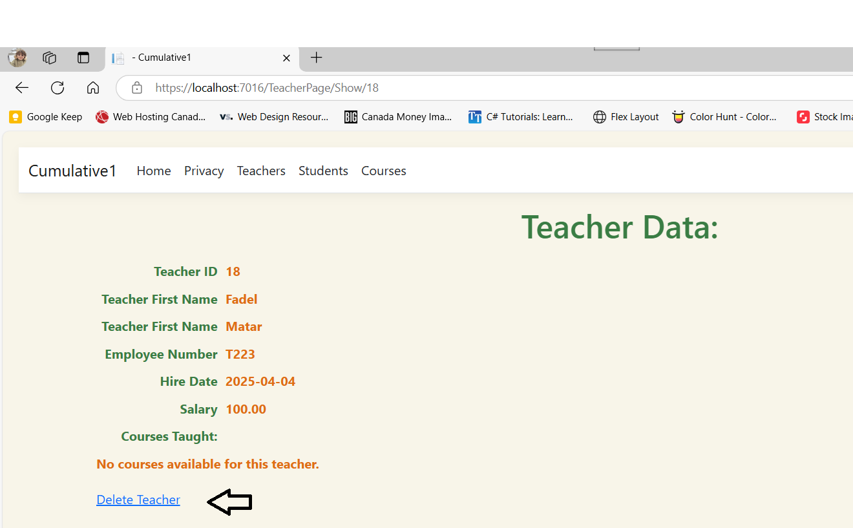

Delete confirmation page, or back to teacher list to cancel

Teacher Fadel Matar deleted (there was a duplicate teacher with the same name, I deleted both)

Error handling:

1. When enter 0 or negative integer on API:

1. If Teacher does not exist:

1. when the Teacher Name is empty (used Object return type instead of Int so I can return both the id or error msg)

source([C# Return different types? - Stack Overflow](https://stackoverflow.com/questions/8986975/c-sharp-return-different-types))

4-Teacher Hire Date is in the future

5-Employee Number is not “T” followed by digits

6- Error Handling on Add when the Employee Number is already taken by a different Teacher, first I add a new teacher, and then tryed to add the same teacher with the same employee number: A screenshot of a computer

7- Add New Student (note: I could add the student via student api and curl, but I had to modify the student table to accept NULL VALUES on student properties to add on the student page, not sure why.

Student added to the list

8 – add student API

9- Student delete API

10- Add Student WebPage:

Student added:

Student show:

10-Student Delete WebPage:

11- Student Delete Confirmation

12- Student deleted (not on the list anymore):

13- Add Course API returns the added course id, since the course id is not auto_increment in the database, I used select max(coursid) + 1 – please check code fyi.

14- add course WebPage:

Course added

Course show

14- delete course API with error handling :

Delete webPage

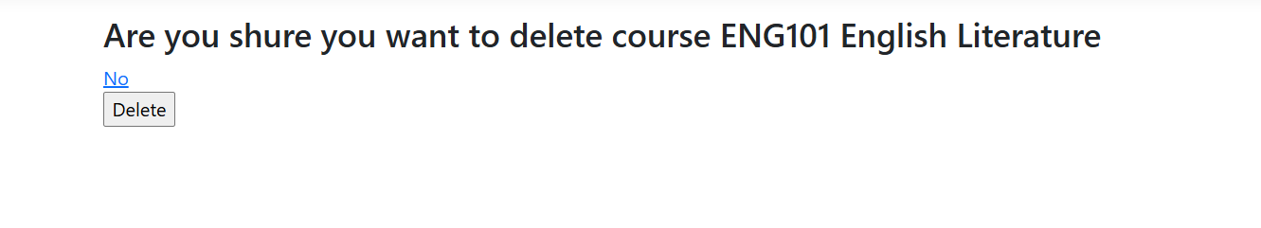

Course deleted from the list

15- Add teacher AJAX (source: Github example)

Teacher Added

16- Delete Teacher AJAX:

Deleted

13- Add teacher Work Phone:

Confirmation

End of document